Exp-4-Working with Constraint

**1. Add a table-level PRIMARY KEY constraint to the EMP table on the ID column. Name the constraint my_emp_id_pk.**

Ans:Alter table emp1 add constraint my_emp_id_pk primary key (id);

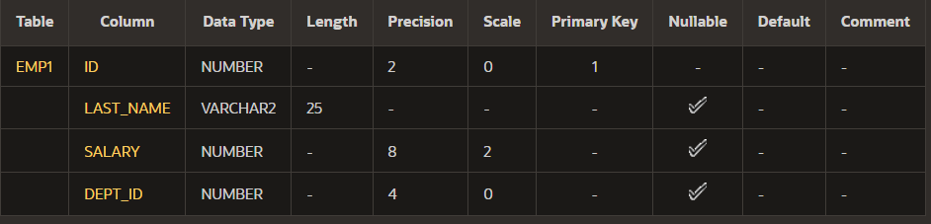

**2. Create a PRIMAY KEY constraint to the DEPT table using the ID colum. Name the constraint my_dept_id_pk.**

Ans:alter table dept add constraint my_dept_id_pk primary key(id);



**3. Add a column DEPT_ID to the EMP table. Add a foreign key reference on the EMP table**

**that ensures that the employee is not assigned to nonexistent deparment. Name the constraint**

**My_emp_dept_id_fk.**

Ans:alter table emp1 add dept_id int;

alter table emp1 add constraint my_emp_dept_id_fk foreign key(dept_id) references dept (id);



**4. Modify the EMP table. Add a COMMISSION column of NUMBER data type, precision**

**2, scale 2. Add a constraint to the commission column that ensures that a commission value is**

**greater than zero.**

Ans:alter table emp1 add commission number(2,2);

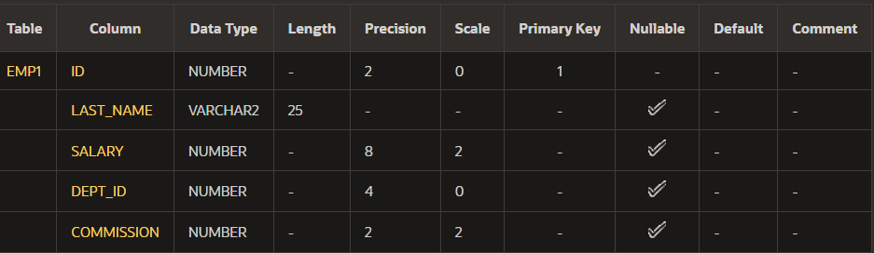

alter table emp1 add constraint my_emp_commission_ck check (commission>0);



**History:**

